**Microsoft Excel:**

**Sensitivity Analysis & Conditional Formatting**

### **Microsoft Excel**

* Go to the Course Website
* Download and print “Business Analytics – Week 3 Instructions.doc”
* Download “Business Analytics – Week 3 Excel.xlsx”

**Session 3.3: One-way Sensitivity Analysis**

Sensitivity analysis allows you to see the effect of a changing variable on an outcome variable. In the example below, use the spreadsheet tab Sensitivity.

The spreadsheet provides the demand curve, costs, revenue and profit for a widget. By changing the price, you can observe the effect on sales and profitability. But this approach only allows you to look at one price at a time. Using the Sensitivity spreadsheet, we will build the spreadsheet shown in the diagram below.

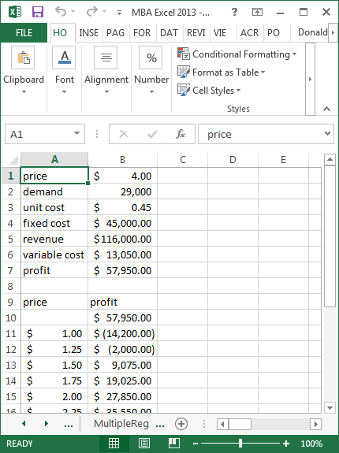

The following steps build a table to examine the effect price has on profits, revenue and costs.

1. To set up a one-way table, enter the labels of your one input variable and all of the output variables in a row. In this example, enter price in A9 and profit in B9.
2. Next, enter a column of prices under price **but skip the first cell below the word price**. In this example, enter a column for price with price ranging from $1 to $4 by $0.25 increments.
3. Immediately under profit in cell B10, enter =B7, so the profit calculation is filled in.
4. Finally, we will create a data table. Highlight the fields immediately under the labels and continue until all of the prices are highlighted. In this case, we highlight A10:B23. Click on the Data tab at the top of the page, click on What-If Analysis, Data Table, then enter in the column input cell the cell reference for variable that you want to vary (i.e., $B$1, which is price), then click OK. This should populate the data table.

What you really did: The price column represents on which prices you would like to perform a what-if analysis, and the three formulas are the outcomes that you want to analyze when price changes. The first step was to set up the price points and the formulas. When you created the data table, you identified what variable changes, but used an absolute address.

**Session 3.4: Two-way Sensitivity Analysis**

If you want to change two variables at once, we create a two-way table. In this example, let’s change both price and unit cost for our widgets. The result that we want will look like the picture below.

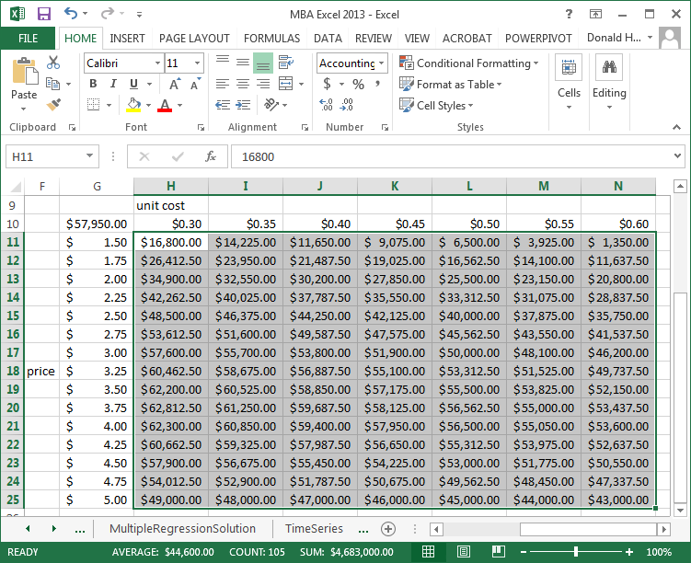

Note that in a two-way table, you can only have one outcome variable. In this case, let’s use profit as the outcome variable. The following steps create a two-way what-if analysis:

1. As before, enter a column for prices. In the picture, the prices are in cells G11:G23. You can type a label of price to the left of any cell.
2. Enter variable costs in H10:N10 from $.30 to $.60 in increments of $.05. You can enter a label for variable costs above the first entry (cell H9).
3. The price column and variable cost row will form the boundary of the table.
4. Now enter the formula that you want to calculate where the column and row intersect, in this case, cell G10. The formula we want to use is for profit; enter =B7.
5. Now highlight the entire table of prices and variable costs G10:N25. Click on the Data tab at the top of the spreadsheet, then What-if Analysis and Data Table. Since the variable that we are varying across the row is unit cost, and unit cost is a named variable, enter unit cost for the row variable. Likewise, since price varies down the column and is named variable, enter price as the column variable. Click OK.

**Session 3.5: Conditional formatting**

Conditional formatting allows you to display data differently based on the values of the data. For example, you can change the font color, background color, or other characteristics to make the data jump out at you when it satisfies certain conditions. Let’s convert the data in the Sensitivity spreadsheet to something more visual.

1. Continuing to use the Sensitivity data, highlight cells H11:N25.
2. Click on the Home tab, Conditional Formatting, Color Scales, then select a color scheme from the right.

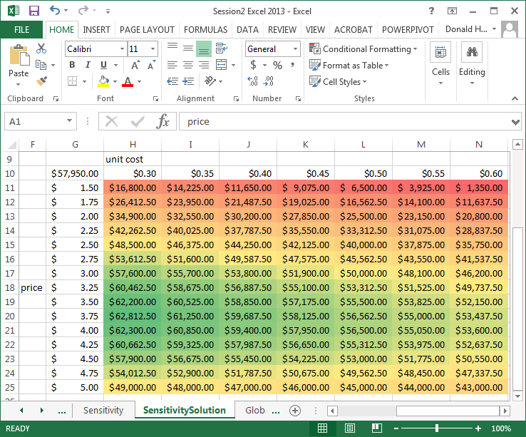

For the next example, use the Global Warming spreadsheet. In the column labeled “top ten red…”, we will use conditional formatting to change the background based on the values in the column. To do this, use the following steps:

1. Highlight the values B3:B152
2. Click on the Home tab at the top of your spreadsheet.
3. Click on Conditional Formatting, Top/Bottom Rules, Top 10. Note that in the next screen, you can change top 10 to top anything. Select red as the color, then OK.
4. Click on Conditional Formatting a second time, Top/Bottom rules, Bottom 10. Change the font and background color to match the column heading.
5. For the next column, use the same approach but select the top and bottom 10%.
6. For the last column, use the same approach but select above and below average.

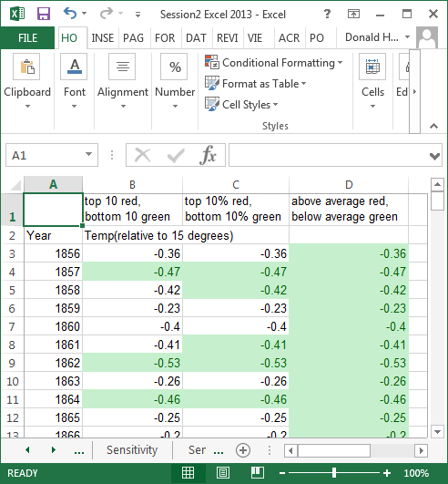

A feature of Excel is data bars to enhance data display. Data bars, color scales and icon sets can be used to enhance tabular data. Using the spreadsheet Experience, the steps to implement these new features are listed below.

1. Select the range of values under the title students.
2. Click on Conditional Formatting.
3. First try Data Bars, and place your cursor over the options that appear on the right.
4. Next try Color Scales, placing your cursor over the options on the right.
5. Finally try Icon Sets, again placing your cursor over the options listed.
6. For each of these features, you can click on more rules and specify additional combinations.

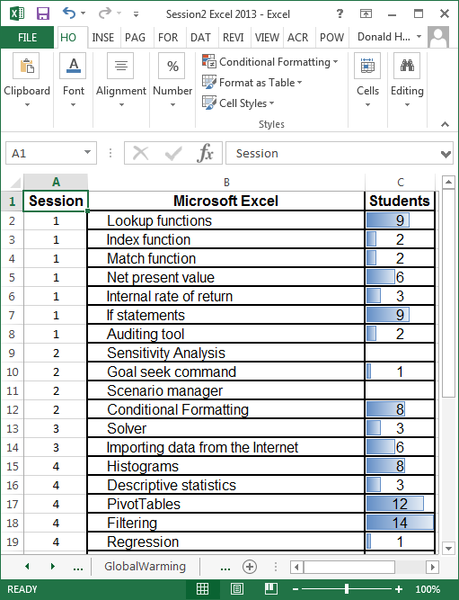

**Session 3.6: Dashboards in Excel**

Dashboards allow multiple views of the data to be displayed simultaneously. For this exercise, use the tab labeled DashboardData. The data reflects orders of products by various customers and shipped by three shipping companies.

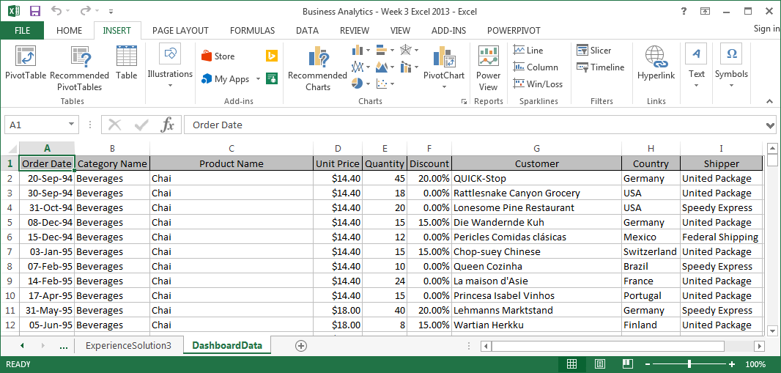

The Order Date field identifies each order by specific day. Let’s create two new columns and calculate the year and month for each order.

1. On the home tab, click on A above the first column, then click Insert, Insert Sheet Columns. Do this twice to insert two new columns to the left of your data.
2. Enter Year in cell A1; Month in cell B1
3. In cell A2, enter the formula =year(C2)
4. In cell B2, enter the formula =month(C2)
5. Copy the formulas down for all data

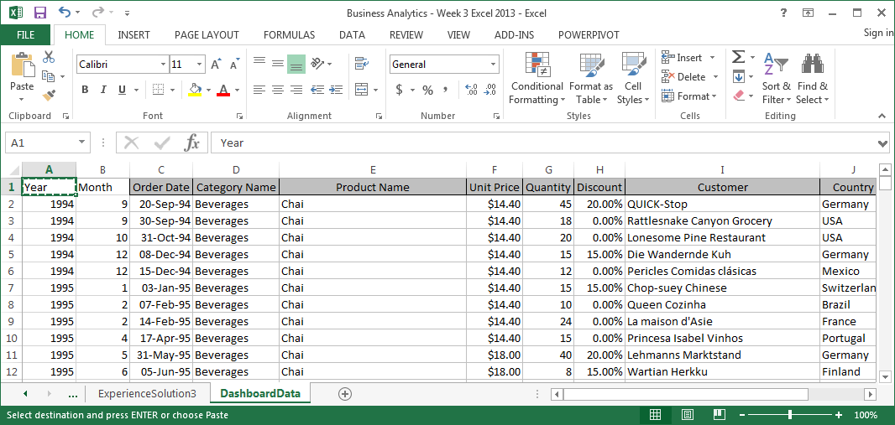

Next, insert a Pivot Table.

1. Click on the Insert tab, then Pivot Table
2. Drag Year to Filters (we will only use 1994 data)
3. Drag Month to Columns
4. Drag Category Name to Rows
5. Drag Quantity to Values
6. In cell B2 of the Pivot Table, use the drop down arrow to change All to 1994.

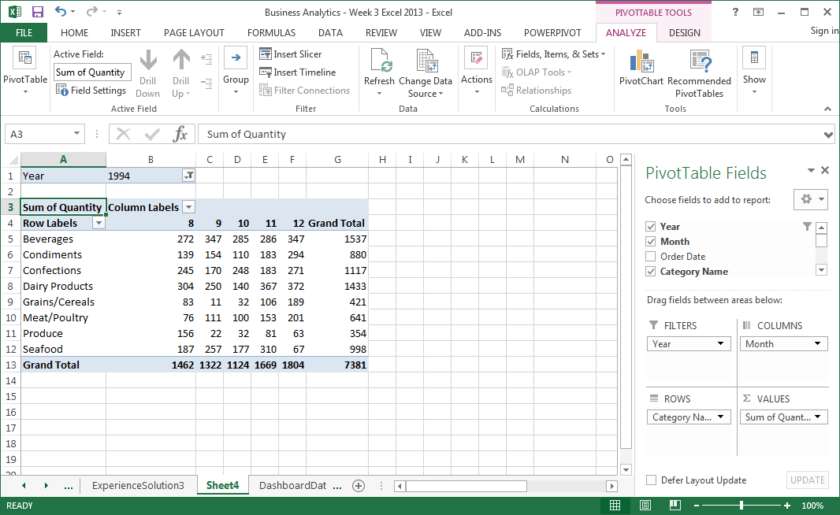

Now, let’s insert a sparkline graph to the left of the data by first creating a column to the left of the Pivot Table.

1. Click on the letter A at the top of the first column.
2. On the home tab, click on Insert, Insert Sheet Columns
3. Highlight the quantity data in cells C5 to G12
4. Click on the Insert tab at the top of the screen
5. Click on Sparkline: Line
6. In Location Range, enter A5:A12, the location to put the sparkline graphs
7. Click OK

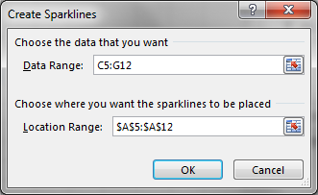

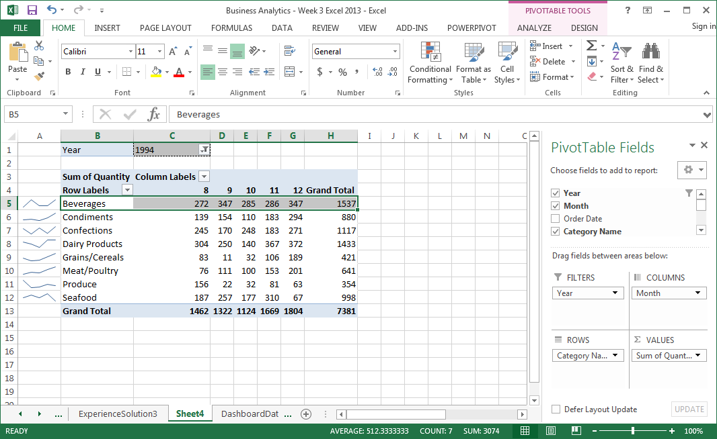

Finally, let’s add a slicer, the ability to filter data on the fly.

1. Click on the Insert tab
2. Click on Slicer
3. Select Country, then OK

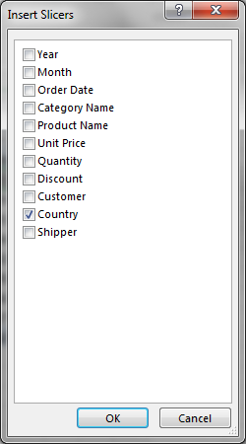

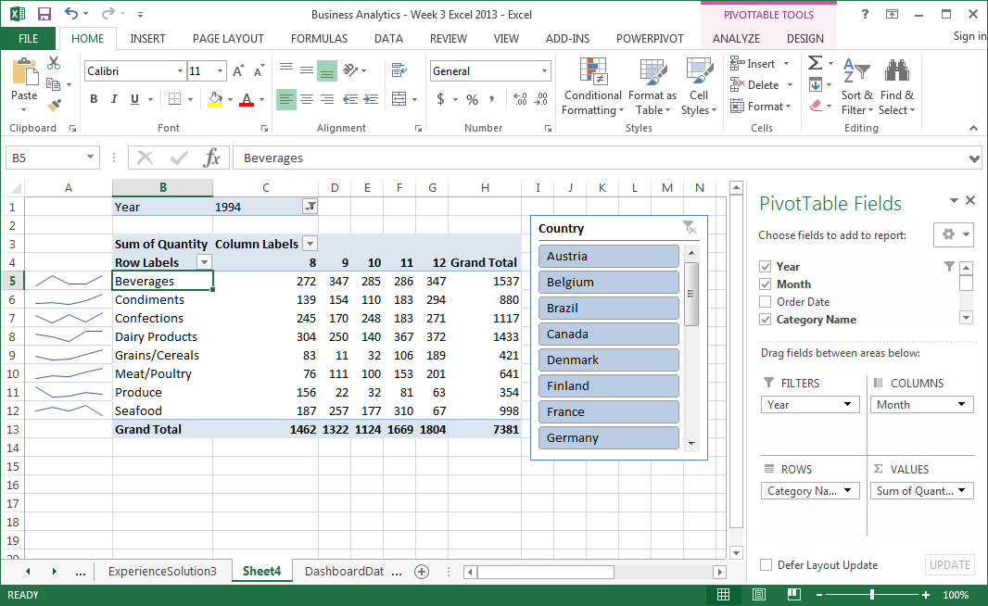

The Pivot Table and Sparkline initially shows all countries (note that countries are all highlighted in blue). By clicking on Austria, we can view only the data for Austria. By holding down the control key, you can select multiple countries. Click on the picture of a filter to the right of Country to restore all countries.

